How to Copy and Paste in SRM Elab

Step 1:

Use This Extensions to copy and Paste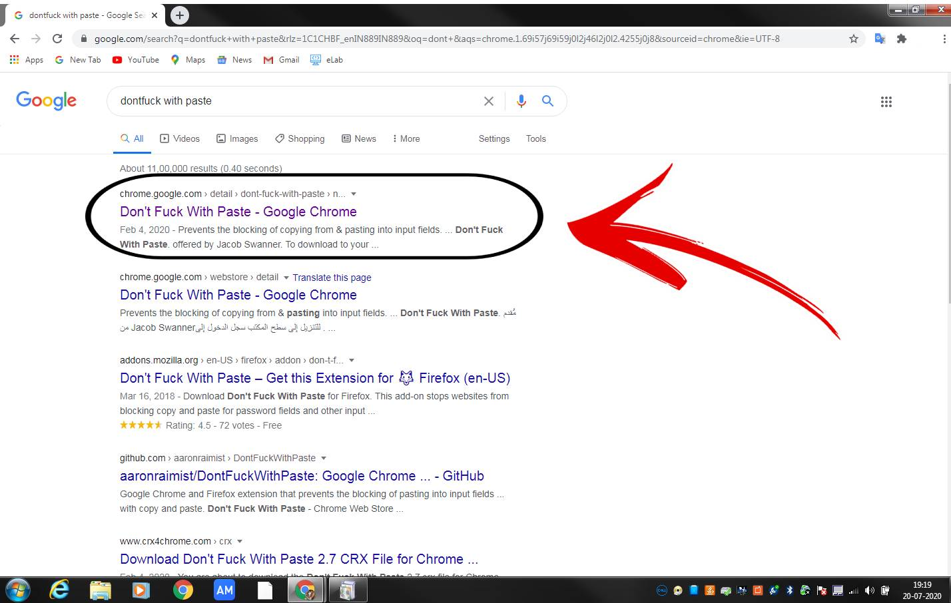

Use This:

<https://chrome.google.com/webstore/detail/dont-fuck-with-paste/nkgllhigpcljnhoakjkgaieabnkmgdkb?hl=en>

Step 2:

Click Add To Chrome and Wait For Few Sec…..

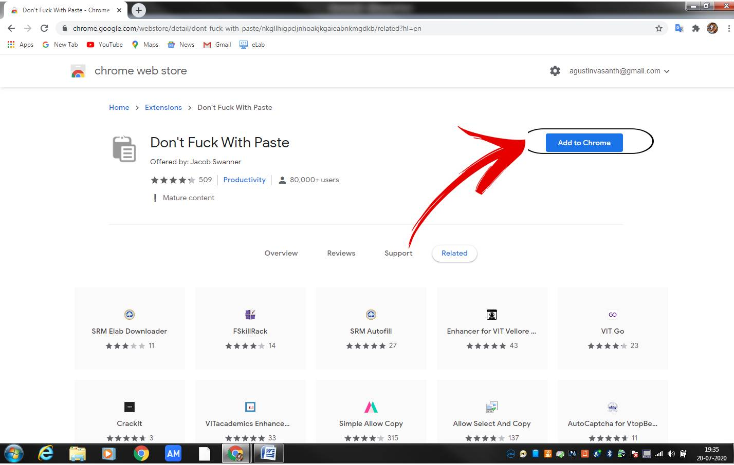

Step 3:

Click Add Extension…..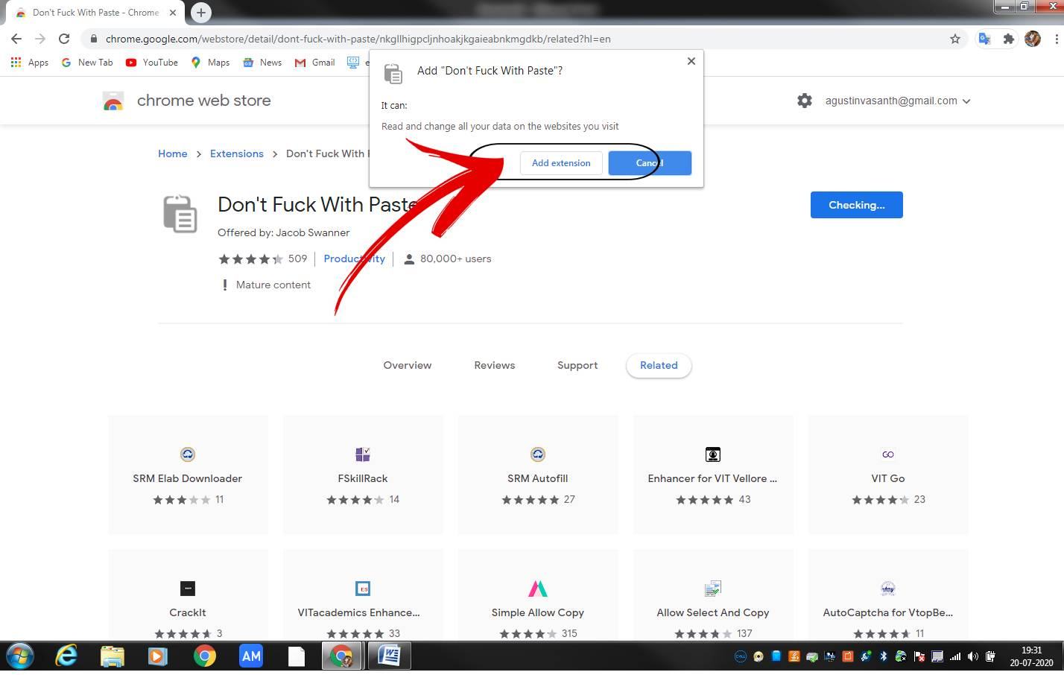

Step 4:

Login Srm Elab Then you can find top right side one puzzles symble…

There You Find Don’t Fuck With Paste Extension… Click It….

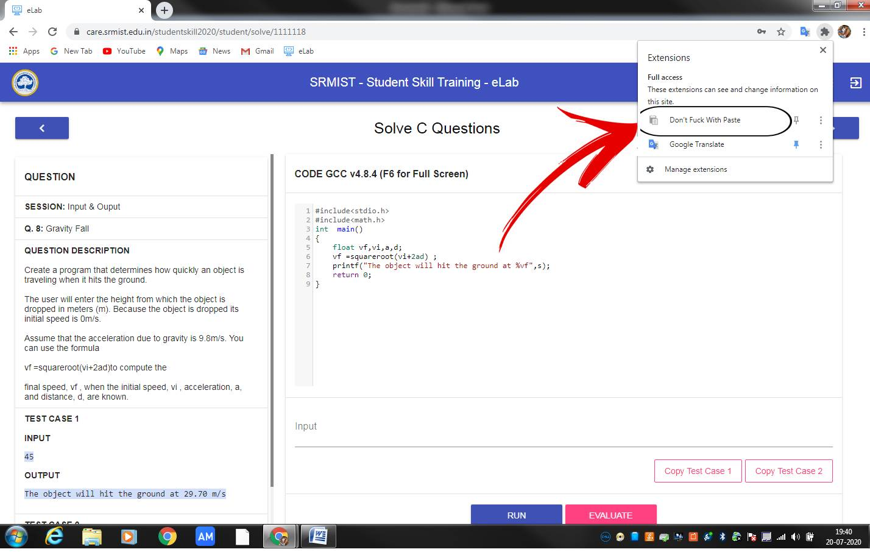

Step 5 :

Click The Save Button….

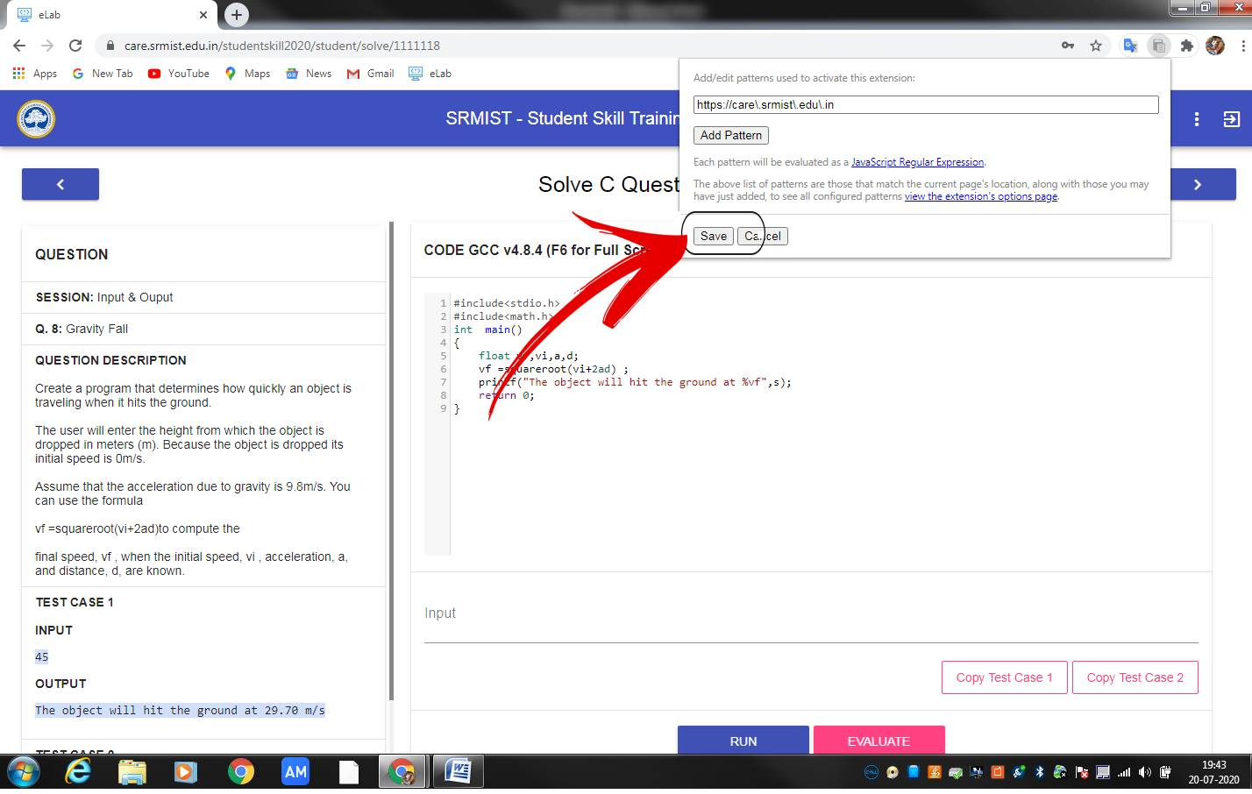

Step 6:

Then Reload This Elab Page……

Then Ctrl + C For Copy

Ctrl + v For Paste